Assignment 1.1: Analyzing the Evolution, Colliding Trends, and Strategic Implications of a Technology

In this module, you learned how to assess technologies by using Gartner’s Hype Cycle and the S-Curve. You also learned how to seize opportunities when facing disruption by using the FLP IT model.

In this assignment, you will pick a new or legacy technology that is central to the product offerings of your organization or an organization of your choice. You will then analyze the current stage and potential future trajectory of this technology and evaluate its strategic implications for your organization.

In a written submission of three to five paragraphs, answer these questions:

* What new or legacy technology in your organization do you want to focus on?
* Where is the technology on the S-Curve? Where is it on Gartner’s Hype Cycle? Explain your rationale.
* Among these [disruption forces](https://student.emeritus.org/courses/3412/files/1739787?wrap=1)[Download disruption forces](https://student.emeritus.org/courses/3412/files/1739787/download?download_frd=1), which forces are most relevant for this technology's continued evolution?
* Collide these forces with one or two technology trends that we foreshadowed in this program. Do you see a new theme or new operating logic evolve in your technology's market? What are some strategic implications for your organization?

This assignment should be 300-500 words and will take approximately 30 to 45 minutes to complete. You will receive personalized feedback from your learning facilitator.

My company Deluxe has been found more than a century ago by an entrepreneur who invented a little product that changed banking which is called checkbook. He had a great dedication to his work with this big idea and achieved his dream by taking only $300 small business loan. We want to follow up our founder and move the flag to the zenith of our dreams. Furthermore, we’ve transformed from “the check company” into a partner that can deepen customer relationships through trusted, technology-enabled solutions – with the talent and skill of each and every one of our employees, and the portfolio of strategic acquisitions that make up Deluxe today. With one eye on our legacy and our founding principles, we’re poised to power an ever-changing business landscape. Today we have 4 million active small business customers and more than 4,000 financial institution clients. We've hosted more than 1 million websites for individuals and businesses. We have a North American network of approximately 300 distributor-franchisees serving local businesses.

In order to accomplish our expectations and serve better to our clients, my focus will be packaged business capabilities (or PBCs) which refers to a business service that can stand alone and can by consumed whole by the end client. Since we are working in an agile environment, this enables me to make small improvements on the fly based on the changing demands of the customers. Thus, they should be small scope, fully autonomous, and consumed as a whole by the end user. They sometimes called micro services which are generally created by using APIs.

Packaged Business Capabilities can be found in the innovation trigger step of the Hype Cycle for emerging tecs, 2020 and it has still had 2 to 5 years to reach the plateau of productivity and this is ok for my company; we can adapt ourselves in terms of planning to take necessary steps in human resources, attracting the required talents, finding needed capital and planning the order of actions.

It seems we are at the beginning of the S curve and up to now we have very little benefited from this approach, however we need to align this new strategy with other strategies we are following up and take required actions and create a harmony in the C- Suite level as well.

My assumption regarding the disruption forces would be in Technology and Politics. From tech side Global dominance of FAANG, especially Facebook has an interest with small business companies. It is providing them $100M in cash grants. Which is very disruptive move for us. On the other hand at the political side, regulation of data capture and securing large amount of data seems another part of the equation.

As a company one of the best move for us might be more collaboration with the companies like Facebook and close work with the government agencies like U.S. Small Business Administration, keep company agile try to create best platform to attract more small businesses and fulfill their expectation and to do this work closely with them.

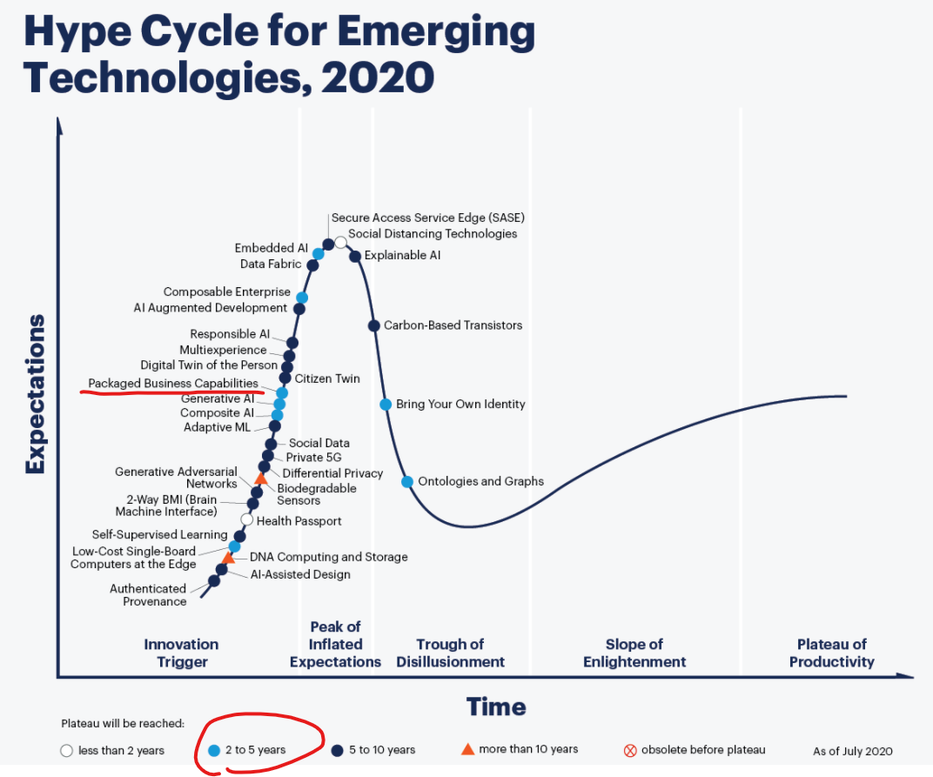

Since my company is dealing with small business companies …

